Computer Workshop 1.1: Hidden Assumptions
Roos & Pinard
Last updated: 2024-08-15
Table of Contents
Workshop Structure 1
Learning Objectives 2
Introduction to ggplot2 2
Load the data 2
A simple plot 3
Question Set One 5
Additional geom_ layers 5
Question Set Two 9
Optional: geom_s 9
The good and the ugly 9
The good 10
The bad 11

Workshop Structure
As always, we are using the workflow below to structure the workshops:
- Formulate a research question.
- Perform exploratory data analysis [Focus of today].
- Identify any hidden assumptions [Focus of today].
- Fit an appropriate model.
- Diagnose the model and check assumptions.
- Summarise the results.
- Interpret and provide inferences.
We covered steps 2 and 3 in the previous workshop but we’ll expand your toolkit for doing so today suing data visualisation.

Learning Objectives
- Learn how to use the R package ggplot2 to do data visualisation.
- Consider what constitutes an effective visualisation versus an ineffective one.
- Learn some techniques to make your figures more visually appealing to an audience.
These skills will be used throughout the course.

Introduction to ggplot2
ggplot2 is an implementation of the “Grammar of Graphics,” a framework for data visualisation. It allows you to build plots layer by layer, starting with a base plot and then adding additional elements such as scales, themes, and geometries. Familiarity with ggplot2 is occasionally asked for by employers; we’ve even seen job adverts from companies such as Spotify listing this an an essential criteria.
It is important to note, however, that ggplot2 is not the only way to create visualisations. It’s just an increasingly preferred one. Many of the figures you will make on this course can be near-perfectly recreated using the visualisation framework offered by base R. We simply prefer ggplot2 as we feel it is a more intuiative way to create figures; indeed, nearly every single figure you have and will see on this course were produced in ggplot2.

Load the data
For the first part of this workshop, we’ll be working with data on the Amazon river dolphin, or the boto (Inia geoffrensis - I wonder if the dude who named it called it after their friend Geoff…). Specifically, we’re interested here in seeing if there is sexual dimorphism in asymptotic length (i.e. once an animal has stopped growing) between females and males. As always, before we do any analysis, we need to ensure there is nothing weird in the data. In workshop 1 you did this by using simple summary statistics (e.g. mean()). While doing so is useful, complimenting this with data visualisations is really powerful.
Start by downloading the data from today’s practical folder, called boto.txt.
Go through the same steps as yesterday to load in your data; create a new script in RStudio, set your working (e.g. setwd("H:/BI3010/workshop2")), then load the data:
boto <- read.table("boto.txt", header = TRUE)
Given how easy it is to do, let’s do a quick summary() and str() to see if anything stands out:
summary(boto)
str(boto)
If nothing immediately seems off, we can continue.

A simple plot
We’ll build this figure up slowly, one layer at a time, to make the fundamental philosophy of ggplot2 clear. To begin with, we can simple make a “ggplot”:
ggplot()

Cool… A completely empty canvas. Well, it shouldn’t really come as a surprise that there’s nothing in this figure. For starters, we haven’t even told it which dataset to use. Let’s correct that now:
ggplot(boto)
Still nothing. What we’re missing here is where we tell ggplot2 a couple of things. First, we need to say in what form we want to the data to be shown. Do we want points? Or lines? Or errorbars? Secondly, we need to say which specific data, or “aesthetics” (shortened to aes() in ggplot2), we want shown and where. Do we want length included? On the x or y axis?
Let’s have length be on the y-axis and drought be on the x-axis. And the form (or geometry) that we want this data to be shown will be as points:
ggplot(boto) +
geom_point(aes(y = length, x = drought))
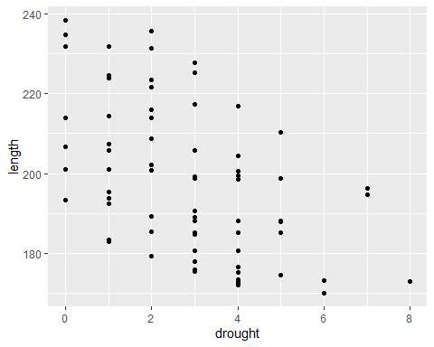
Now we’re getting somewhere. From an early data analysis perspective, what have we already learnt just from the quick summary stats and from this figure?

Question Set One
- What variables do we have available to us?
- How many observations/samples do we have?
- Is the relationship between boto length and number of drought years likely to be positive, neutral, or negative?
- What range of lengths do boto dolphins reach at maturity?

Additional geom_ layers
The above figure is great. It’s simple and clear (though a bit ugly - we’ll come back to that later), but how would we include a categorical variable like sex? Can we just copy our code from above and replace drought with sex? Let’s see:
ggplot(boto) +
geom_point(aes(y = length, x = sex))
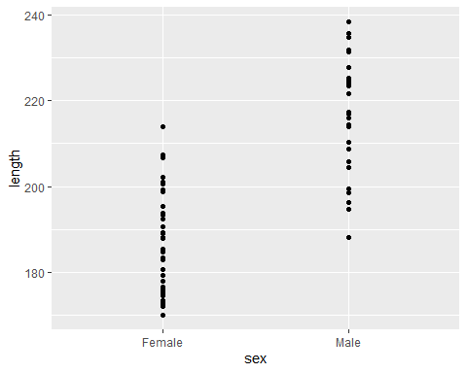
Kind of? It’s a bit hard to see the spread of data for each sex. A better way to show this is to use some sort of tool which will show help the reader understand the range of length for each sex but also how the data is spread. There are two common options people use for this; boxplots and violin plots. It’s trivially easy to swap between these, because all we need to do is change the geometry function from geom_point() to either geom_boxplot() or geom_violin():
# Boxplot
ggplot(boto) +
geom_boxplot(aes(y = length, x = sex))
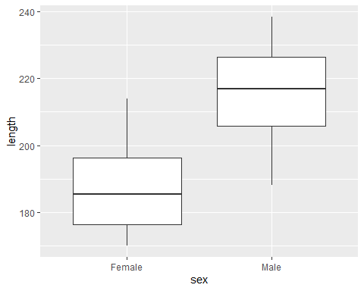
# Violin plot
ggplot(boto) +
geom_violin(aes(y = length, x = sex))
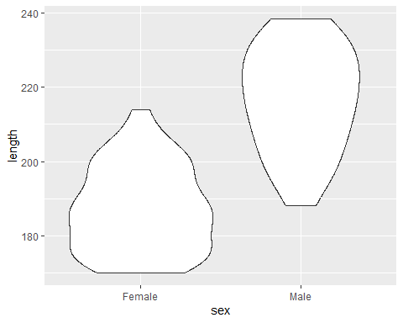
Both of these present the same information in different ways. The boxplot uses boxes and lines to indicate the range, the first and third quantiles and the median. Conversely, the violin plot also shows the spread of data but by creating density plots which are mirrored. Boxplots have a long history and use in science, but people are increasingly using violin plots, simply because they’re more transparent than boxplots.
With either boxplots and violin plots, it’s fairly common that people will add the data points to the figure as well - to really hammer home the spread of data. But we’ve seen before that using geom_point() basically gives us a line of points that doesn’t help us understand the spread at all. An alternative is to use something called “jiterring”. When we jitter points, we add a small random value to either or both the x and y position to spread the data out a little bit. With our boto data above, we wouldn’t want to add anything to y (as we’re interested in the length of the dolphins, so we don’t want to mess that up) but we can happily add something to x (or sex). To do so, we can use geom_jitter() but we want to specify that “noise” should only be added to x and not y. Here’s how we do that:
ggplot(boto) +
geom_violin(aes(y = length, x = sex)) +
geom_jitter(aes(y = length, x = sex), height = 0, width = 0.1)
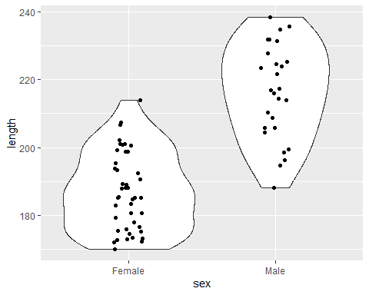
There are two things to note with the above code. First, geom_jitter() comes after geom_violin(). If we put the violin after the jitter, then we wouldn’t see any of the jittered points; They’d be under the geom_violin() layer. Secondly, in geom_jitter(), we don’t add the height = and width = arguments to aes(), as aes() is used to reference information within the boto dataset. Whenever we want to make changes to a geom_ that are not related to the data, we do so outside of aes().

Question Set Two
- What’s wrong with the following code?
ggplot(boto)
geom_jitter(aes(y = length, x = sex, height = 0, width = 0.1))
- Find the error in this code:
ggplot(boto) +
geom_point(aes(x = length, x = drought))
- Find the error in this code:
ggplot(boto) +
geom_point(aes(x = length y = drought))

Optional: geom_s
Have a look here, specifically at the layers section. Using the information in the link, see if you can figure out which geom_ to use such that you recreate the following figure. There are two things to note here. First this figure is created with a single geom_ with only x = and y = specified, and no other options. Secondly, if you figure out which geom_ to use, you will be prompted to install a new package when you run the code (it’s fine to install this new package - simply type 1 and enter in the console to do so).
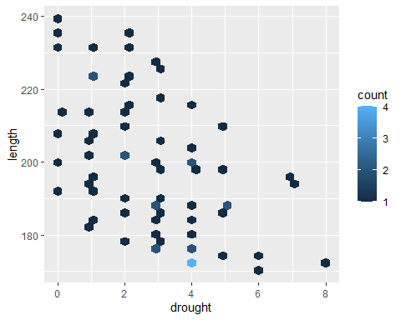

The good and the ugly
abdn <- read.csv(here("Workshops/Workshop 2 - Data vis/Data", "abdn_flats.csv"), header = TRUE)
We’re going to do something that’s, hopefully, fun but also instructive. On MyAberdeen, you find a dataset called abdn_rent.csv (note that this is a .csv file extension and not a .txt, so you’ll need to use read.csv() rather than read.table() when loading the data). This dataset contains 130 records (i.e. observations or samples) of rent prices for properties listed in Aberdeenshire on the ASPC website, and 11 additional variables. The variables included are:
- price - the rent of the listed property
- beds - the number of bedrooms in the property
- living - the number of living rooms in the property
- baths - the number of bathrooms
- sqmt - the total floor area of the property (measured in m^2)
- epc - th Energy Performance Certificate (A is highly energy efficient, G is terrible)
- tax - the council tax band (which is based on the value of the property on 1/4/1991, A is the lowest council tax, H is the highest possible)
- date - the date when the record was added to the dataset (note this is not when the property was listed on the site)
- link - web link for the property listing
- house - the property name or address
- lat - the latitude coordinates of the property (note latitude is North to South - think of a “ladder”, sounds kinda like “latter” going up)
- lon - the longitude coordinates of the property (note longitude is East to West - think of “the long way around”)
Spend a bit of time familiarising yourself with the data, i.e. do a quick EDA to make sure there’s nothing weird. If you find what you think is a mistake, well in this case, you can check and correct yourself, as you have the original data because of the web link! Once you’re happy you know the data, let’s get to the tasks.

The good
Using whichever variables you like, make the most informative and visually appealing figure you can. Imagine you have been hired by a real estate company to create a figure that helps potential renters understand what may be determining rent prices, using R, ggplot2 and the abdn_rent.csv dataset. Curious how much you might get paid to do this?

Look at that salary!
See here for the full job advert.
Create your most informative and visually appealing figure now. Keep the lecture on effective communication in your mind, and avoid some of the pitfalls we discussed. If you need help figuring out how to implement one of your ideas, see Intro2R chapter for a more detailed walk through, or else use your LLM or choice to help. If using an LLM, just remember to mention that you are using R, ggplot2 and do not want to use any additional packages. There is nothing wrong with using additional packages, but they can just add lots of extra moving parts to the mix (and cause conflict issues). We’d suggest you try and limit the number of additional packages you have loaded while you’re still getting the hang of things, but if you feel comfortable using R, then go ahead by all means.

The bad
Now for the part I’m excited about. Do the same as above, but this time, make it a miserably ugly figure. It still needs to contain the information (i.e. no blank figures) and be somewhat readable. If you need inspiration, search for “graph crimes”, or “chart crimes” in your search engine - there are lots of examples you can use for “inspiration”.
Once, you’re happy with your masterpieces, email you’re favourite the whomever is running your session (either Deon or Michelle), and we’ll have an “Art Exhibit” to finish the workshop :D.

